**BUGS**

**BUG_01_ABLE TO CREATE ARTICLE WITH ALL FILED AS BLANK**

**STEPS TO REPRODUCE:**

1. **Login to application**
2. **Click on New Article link**
3. **Without filling any field click on publish article button**

**ACTUAL:** Able to create article without filling any data

**EXPECTED:** Should not allow if filed is blank

**PRIORITY: High**

**SEVERITY: low**

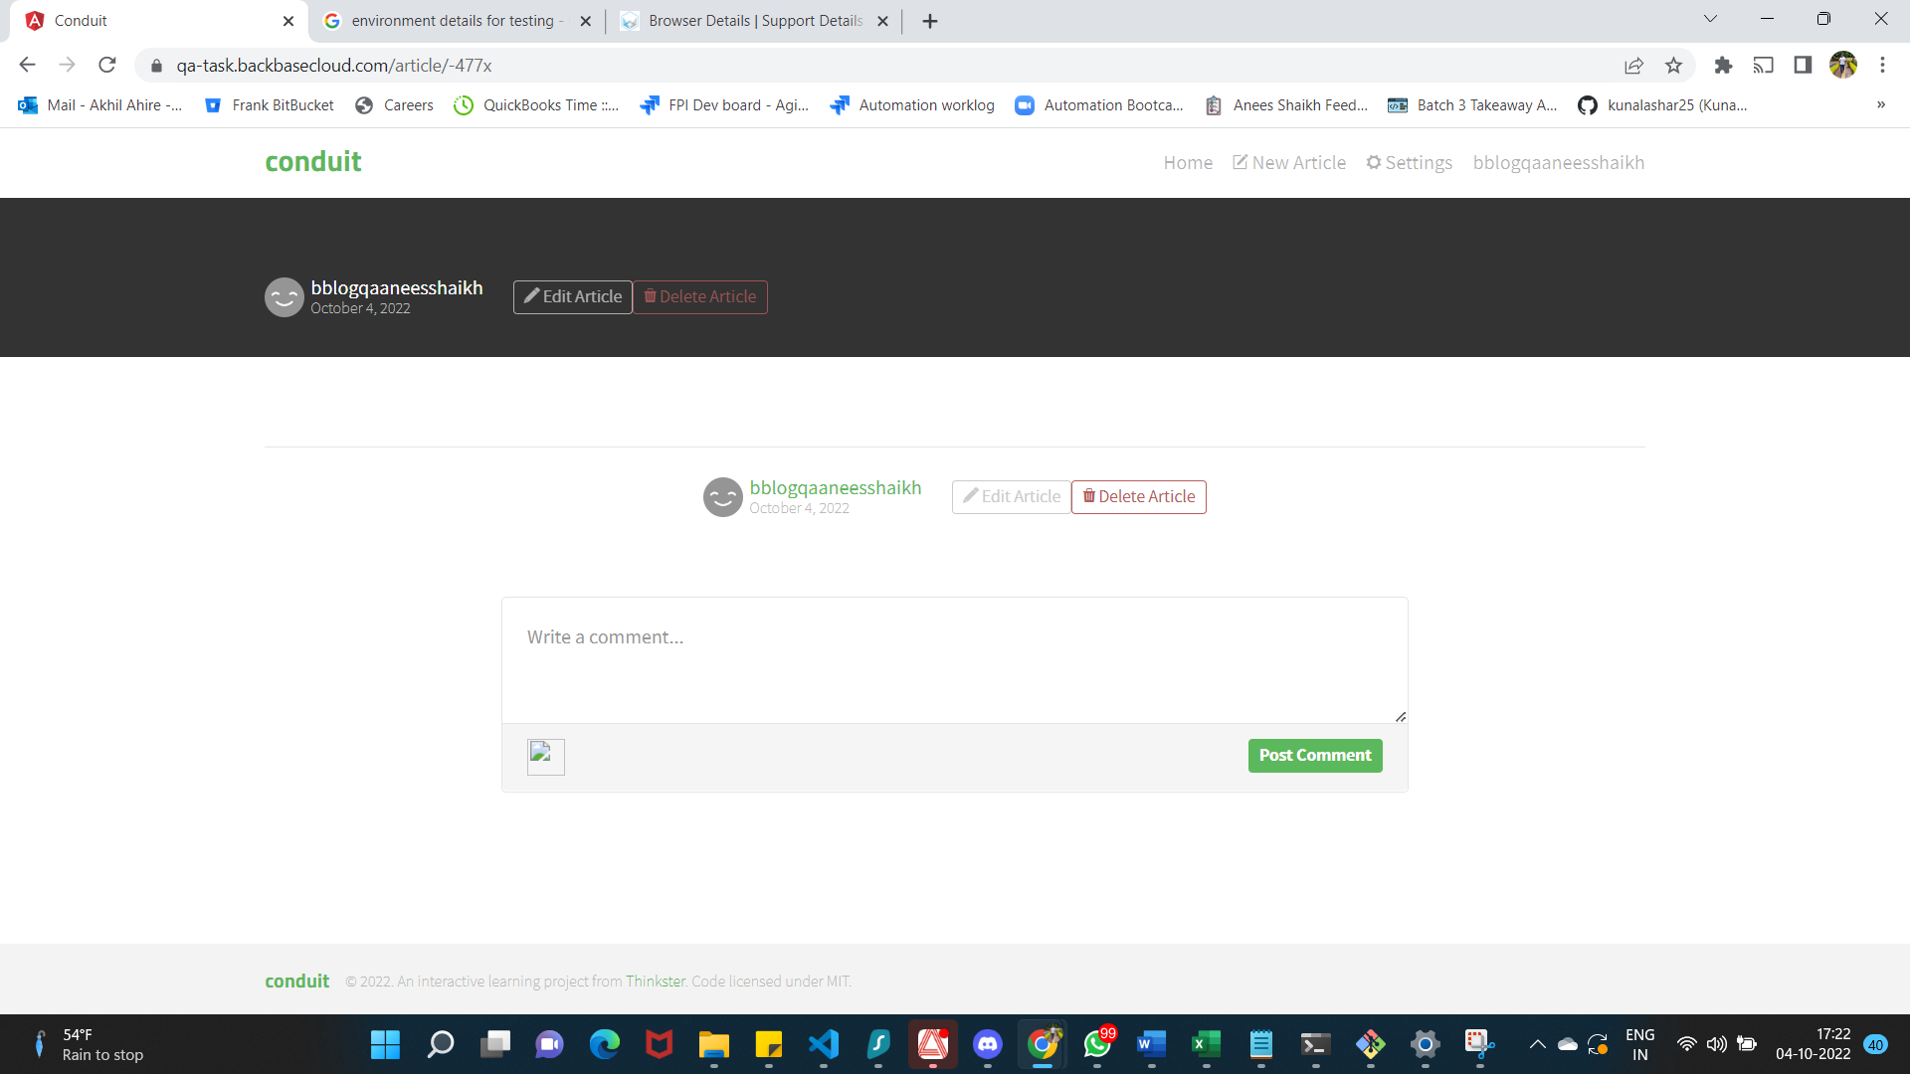

**BUG_02_RFRESH OVER CREATE NEW ARTICLE PAGE GIVE 404 error**

**STEPS TO REPRODUCE:**

**ACTUAL:** Getting 404 error over refresh or reload

**EXPECTED:** Create new article page should be reloaded

**PRIORITY: Medium**

**SEVERITY: Medium**

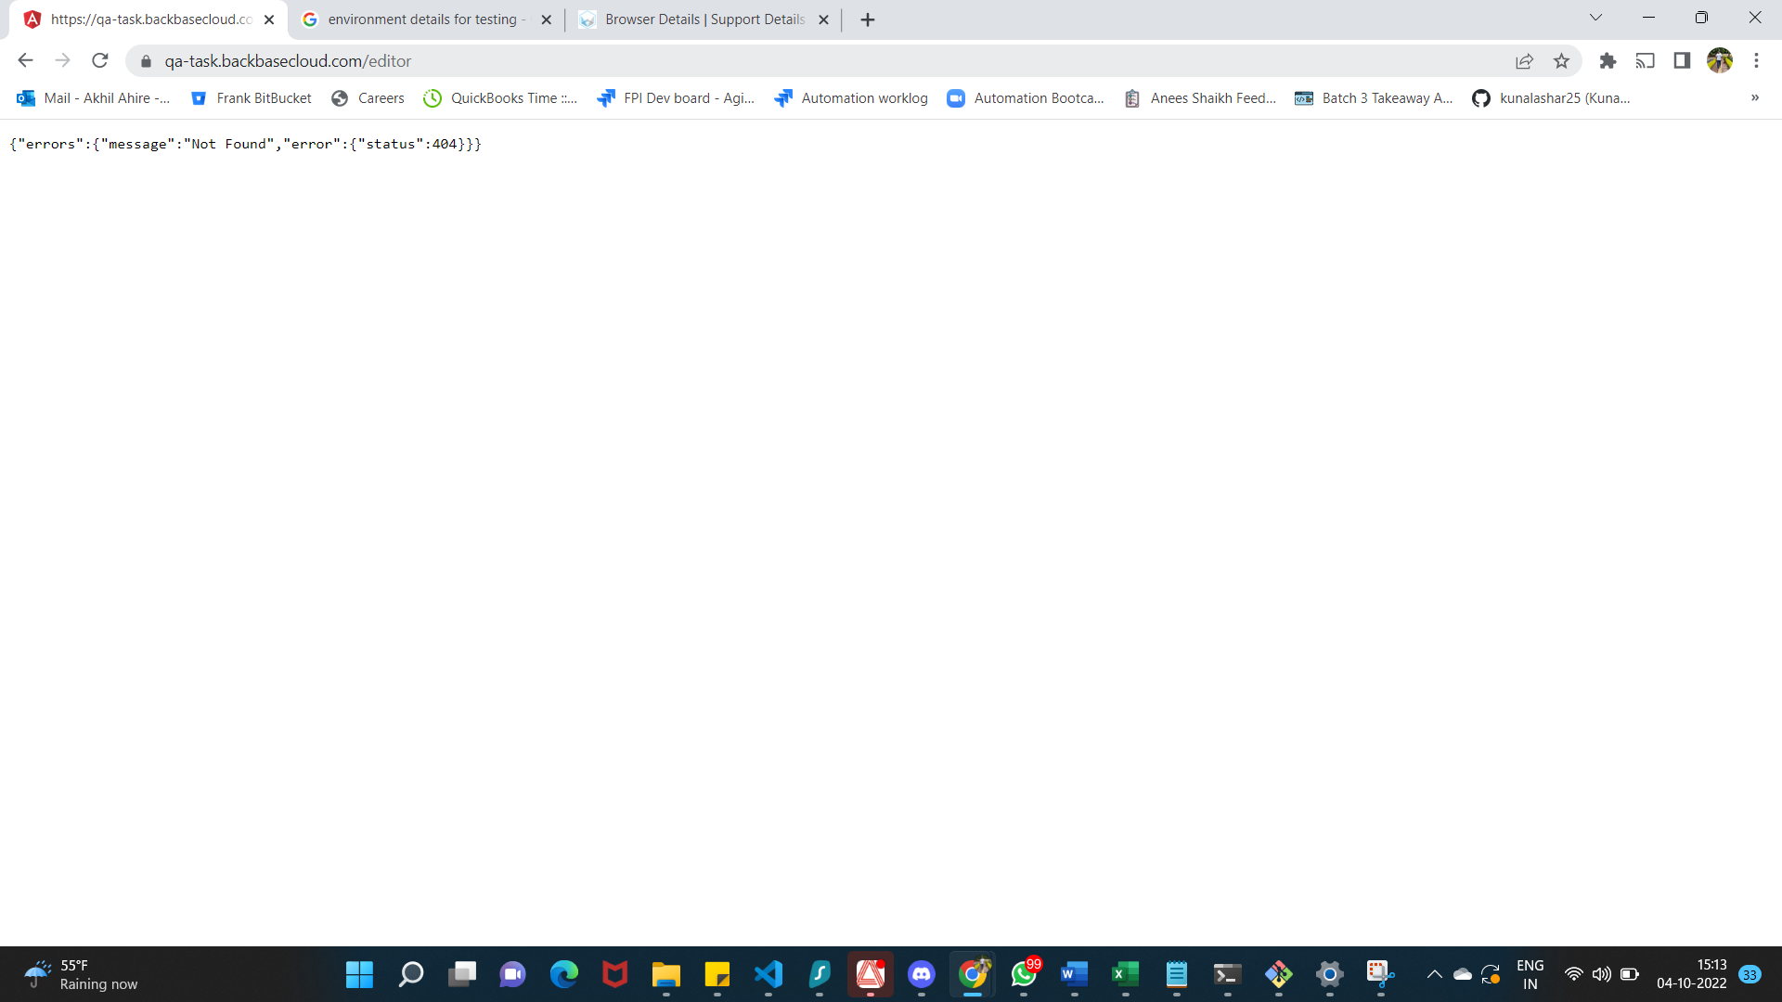

**BUG_03_** **No error displayed if any filed is blank and user try to click on publish article button**

**STEPS TO REPRODUCE:**

1. **Login to application**
2. **Click on New article link**
3. **Fill all filed except title field (repeat similar steps for other fields)**
4. **Click on publish article**

**ACTUAL:** Field specific error is not displayed instead it got updated with blank value

**EXPECTED:** Field specific error should be thrown for blank values

**PRIORITY: Medium**

**SEVERITY: low**



**BUG_04_** **Your feed section over home page is not displaying created or updated articles**

**STEPS TO REPRODUCE:**

1. **Login to application**
2. **Create New Article**
3. **Click on Home page**
4. **Click on your Feed Section**

**ACTUAL:** Article are not getting displayed in Your Feed section of Home page

**EXPECTED:** Article should get displayed in Your Feed section of Home pagew.r.t logged in user

**PRIORITY: High**

**SEVERITY: Medium**

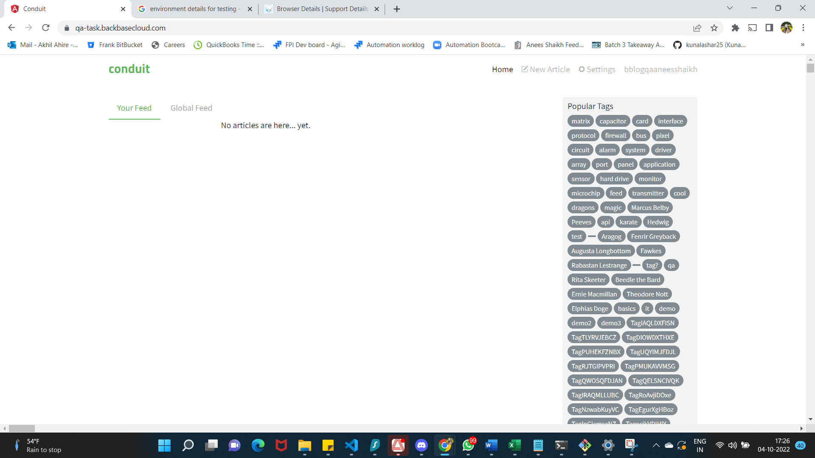

**BUG_05_** **Article Title Text or Body text is not wrapped on article page**

**STEPS TO REPRODUCE:**

1. **Login to application**
2. **Crate article with long title**

**ACTUAL:** Text wrapping is not done properly over article page it looks weird if article is having long words of characters in title

**EXPECTED:** Article Title text should be wrapped in proper way before displaying it

**PRIORITY: Medium**

**SEVERITY: Low**

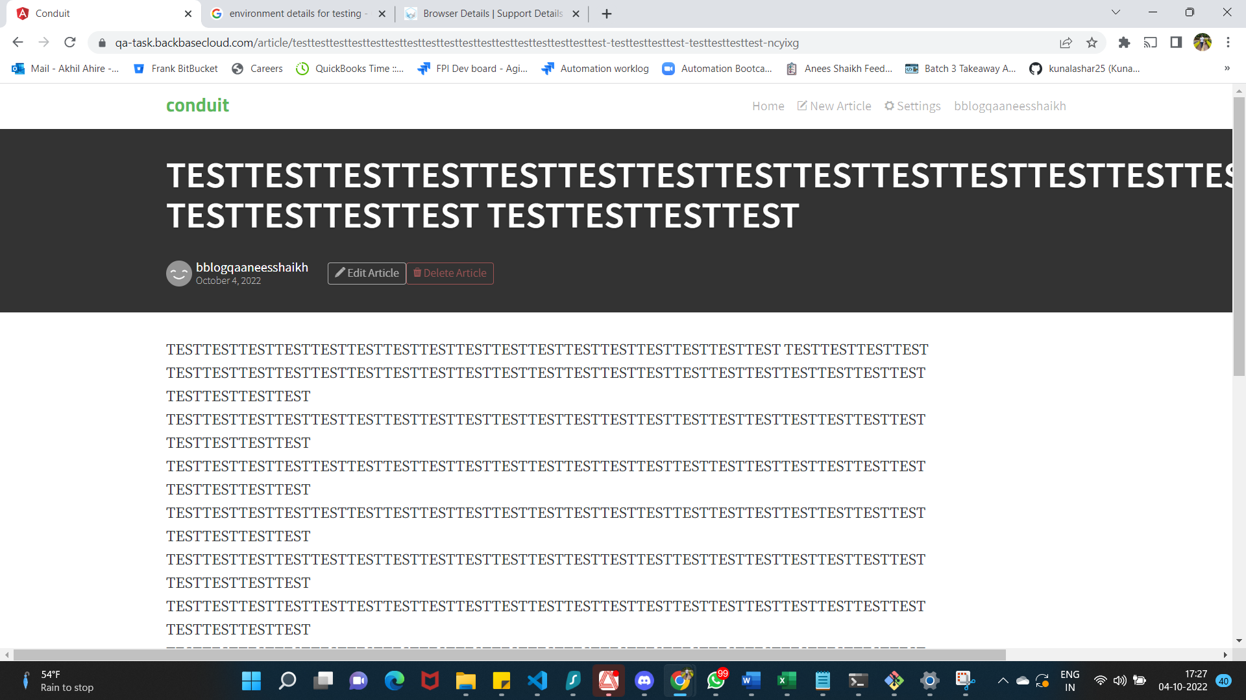

**BUG_07_** **Character length is not defined for each text box present over create article page**

**STEPS TO REPRODUCE:**

1. **Login to application**
2. **Click on New article link**
3. **Enter Text in Title filed**

**ACTUAL:** User is able to enter N number of words and character over text box

**EXPECTED:** Text box character limit should be defined for each text box

**PRIORITY: Medium**

**SEVERITY: Low**

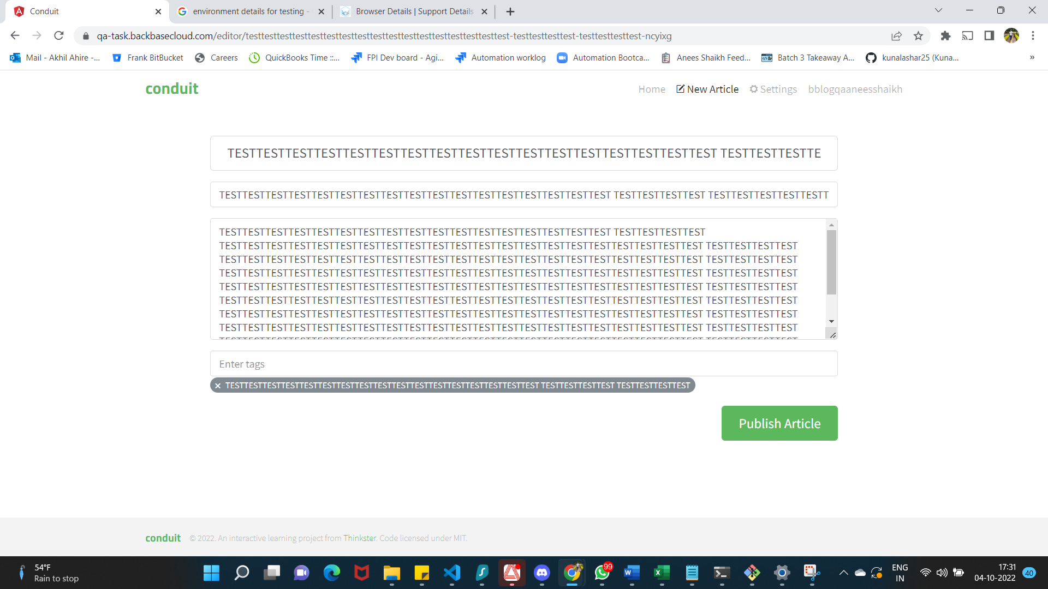

**BUG_08_** **Page is not responsive over mobile emulators or mobile devices**

**STEPS TO REPRODUCE:**

1. **Load application in mobile emulator or device**

**Actual:** Page is not getting loaded as expected in mobile its not responsive

**EXPECTED:** Page should be responsive in Mobile emulator or devices

**PRIORITY: Medium**

**SEVERITY: Low**

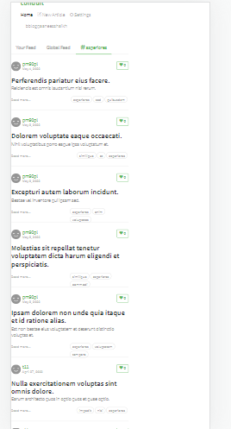

**Recommendations:**

1. **Edit and delete option should be present once on article a page**
2. **Over update article page Button name should be displayed as Update article.**
3. **Suggestion : We can introduce mandatory filed check and if any of the mandatory filed is blank throw an error**